Sort K sorted array
Problem Statement: Given an array arr[] and a number k . The array is sorted in a way that every element is at max k distance away from it sorted position. It means if we completely sort the array, then the index of the element can go from i - k to i + k where i is index in the given array. Our task is to completely sort the array.
Input : arr = [6, 5, 3, 2, 8, 10, 9], k = 3
Output : [2, 3, 5, 6, 8, 9, 10]
Explanation : The element 2 was at index 3, it moved to index 0. The element 3 was at index 2, it moved to index 1. The element 5 moved from index 1 to index 2. The element 6 moved from index 0 to index 3. The rest (8, 9, 10) were near their correct spots and shifted slightly.
Input : arr = [1, 4, 5, 2, 3, 6, 7, 8, 9, 10], k = 2
Output : [1, 2, 3, 4, 5, 6, 7, 8, 9, 10]
Explanation : The element 2 moved from index 3 to index 1. The element 3 moved from index 4 to index 2. The element 4 moved from index 1 to index 3. The element 5 moved from index 2 to index 4. All others remained in or near their correct positions.
Algorithm
This approach is built around the core idea of a k-sorted array — where each element is at most k positions away from its correct place. This means that the smallest element in the array must exist somewhere in the first k + 1 elements.
So instead of sorting the entire array, we can use a min heap to efficiently keep track of the smallest elements in a moving window of size k + 1.
By inserting the first k + 1 elements into the heap, we ensure the smallest element among them bubbles to the top. We then remove it and append it to the result. As we move forward, we keep adding new elements into the heap while removing the smallest (root). This way, we always process the next smallest valid number and build the sorted result — while leveraging the k-distance constraint for efficiency. This drastically reduces the time complexity compared to sorting the entire array.
- Initialize an empty min heap
- Insert the first k + 1 elements from the array into the heap
- Start from the (k + 1)^{th} element and iterate through the array
- In each step, remove the smallest element from the heap and append it to the result
- Push the current array element into the heap
- After processing the full array, remove all remaining elements from the heap and append them to the result
- Return the final result array
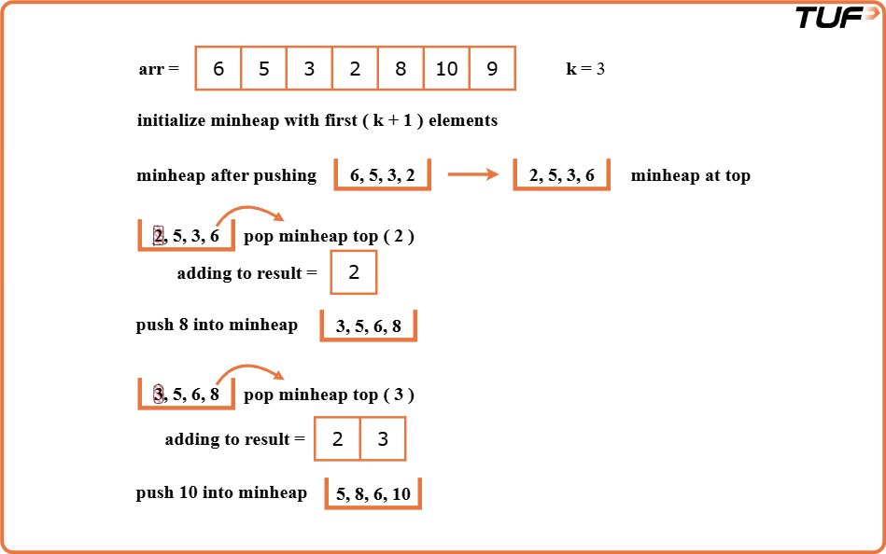
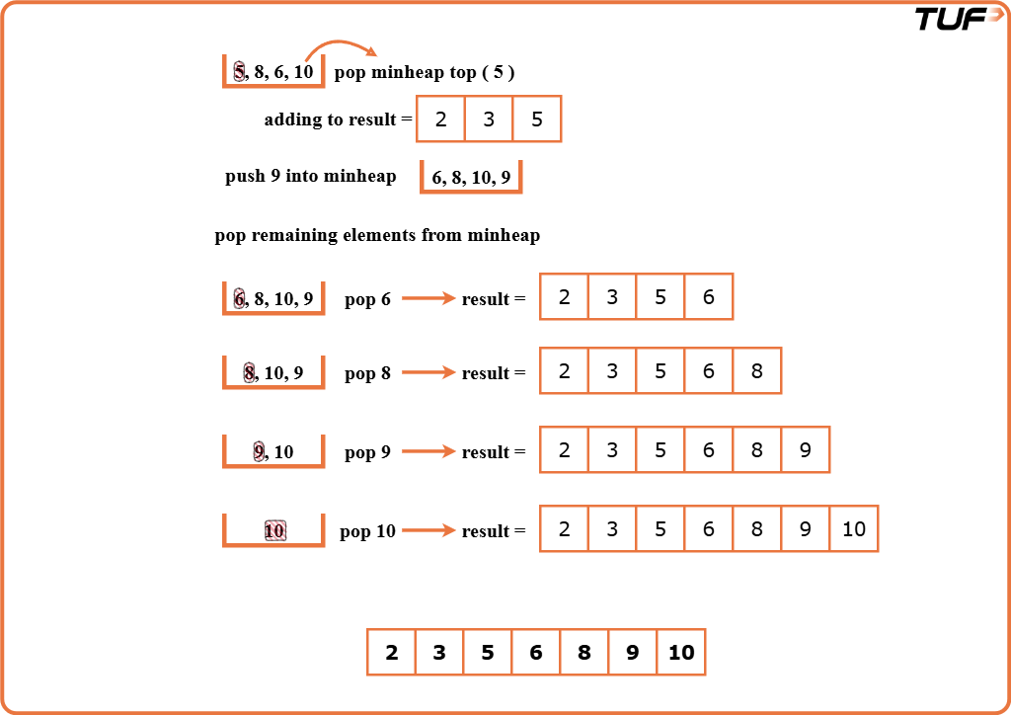

class Solution {
// Function to sort a k-sorted array using a priority queue
public List<Integer> sortNearlySortedArray(List<Integer> arr, int k) {
// Create a min heap using PriorityQueue
PriorityQueue<Integer> minHeap = new PriorityQueue<>();

// Store the final result
List<Integer> result = new ArrayList<>();

// Add first k+1 elements to the heap
for (int i = 0; i <= k && i < arr.size(); i++) {
minHeap.add(arr.get(i));
}

// Process the rest of the array
for (int i = k + 1; i < arr.size(); i++) {
result.add(minHeap.poll()); // remove smallest
minHeap.add(arr.get(i)); // insert current
}

// Remove and add remaining elements in heap
while (!minHeap.isEmpty()) {
result.add(minHeap.poll());
}

return result;
}
}
Time Complexity: O(n log k),We insert n elements into a min heap of size k + 1. Each insertion/removal from heap costs O(log k). So total time = O(n log k).
Space Complexity: O(k),We maintain a min heap of size at most k + 1 at all times.

